## **Software Engineering Process**

**SOEN 6011**

Summer 2016

**Assignment 5**

Group 6

**Prepared by:**

Vivek Khatri 27292848

Navneet Kaur 27676638

Sarvenaz Khaksarfard 40002880

Pardeep Kaur 40014804

Muhammad Raza Khan 27735987

Neha Kumari 27382073

Ankit Lathia 27378327

MiteshKaura 27284756

# General State Diagram

# State Diagram for Difficult level Heuristics

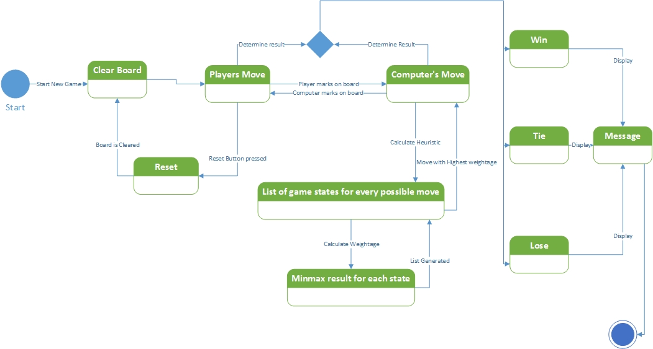

# Description

Our State diagram represents the overall events and states that occur in our version of Tic Tac Toe game. The transition of these main states are caused by the events. The events that occur in the game can be caused by human players or the computer. Our main focus is on the events that the computer causes and the heuristics to do so. However, since we have different heuristics in the form of easy, medium and difficult; we delineate the heuristics for difficult level and try to represent it through this state diagram. For the difficult level, we use MiniMax algorithm for the computer, which tries to block a players move in order to win.

While all the states of a board cannot be represented as it is not viable to do so, the strategy to block a players move can be represented as a general outline in a separate state Diagram.

Essentially, we have two state Diagrams, one of the diagrams represent the overall states and transition for the game, which include both Humans and computer. The second state diagram specifically represents the heuristics used by computer at difficult level in order to block the user’s move and win.

The transition of states in case of difficult level of computer is based on a combination of moves made by the player and the strategy used by the computer to make moves. As a player makes a move, the computer generates a list of all possible states for every move. Furthermore, weightage for each move is calculated by Minimax algorithm, which gives a list of scores based on the efficiency of move in order to win the game.

The best possible state is then picked up by the computer and it marks accordingly on the board. The process then again repeated recursively, after the human player makes a move. This recursive process keeps on going until winner is determined or the game is tied, then a message is displayed to show who won the game or if a game is tied. A winner is tried to be determined after each move. Player can reset the board anytime during the game which leads to a clear board state.